Name

Mathematics Stage 5 Path
Direct and Inverse Variation

Book 1 | Identify and describe problems involving direct and inverse variation | Version: 260511  Feedback:  https://MrDingMaths.com
Contents
Syllabus Content 2
Direct and Inverse Variation 3
Graphs of Direct Variation 7
Graphs of Inverse Variation 11
Solving Direct Variation Problems 15
Modelling Direct Variation 17
Inverse Variation Problems 21

Syllabus Content
MA5-RAT-P-01 identifies and solves problems involving direct and inverse variation and their graphical representations
Identify and describe problems involving direct and inverse variation
- Describe typical examples of direct variation/proportion
- Apply the language of direct variation to everyday contexts: $y$ is directly proportional to $x, y$ is proportional to $x, y$ varies directly as $x$
- Identify and represent direct variation/proportion as $y∝x$ ($y$ is proportional to $x$) or $y=kx,$where $k$ is the constant of variation
- Describe typical examples of inverse (indirect) variation
- Apply the language of inverse variation to everyday contexts: $y$ is inversely proportional to $x$, $y$ is proportional to the reciprocal of $x$, $y$ varies inversely as $x$
- Identify and represent inverse variation/proportion as$y∝\frac{1}{x}$ ($y$ is inversely proportional to $x$) or $y=\frac{k}{x},$where $k$is the constant of variation
Identify and describe graphs involving direct and inverse variation
- Recognise and describe direct variation from graphs, noting that the graph of $y=kx$ is a straight line passing through the origin, with its gradient $k$ being the constant of variation
- Recognise and describe inverse variation from graphs, noting that the graph of $y=\frac{k}{x}$ is a curve
Solve problems involving direct and inverse variation and examine the relationship between graphs and equations corresponding to proportionality
- Solve problems involving direct or inverse variation using an equation
- Use linear conversion graphs to convert from one unit to another
- Graph equations representing direct variation, with or without digital tools

Direct and Inverse Variation

- Direct and Inverse Variation
Two quantities are directly proportional if:
- An increase in one quantity causes a proportional increase in the other.
- If you triple one quantity, the second quantity is also tripled.
- A decrease in one quantity causes a proportional decrease in the other.
- If you halve one quantity, the other quantity is also halved.

Two quantities are inversely proportional if:
- An increase in one quantity causes a proportional decrease in the other.
- If you triple one quantity, the second quantity is divided by 3.
- A decrease in one quantity causes a proportional increase in the other.
- If you halve one quantity, the second quantity is doubled.

- Identify examples of direct and inverse proportion
Decide whether these variables are in direct proportion, inverse proportion, or unrelated.
- The numbers of hours worked and amount of money earned for a wage worker. | - The weight of tomatoes purchased and the total amount paid.
- The number of painters and the  time it takes to paint a room. | - The speed of a car and the  time taken to travel a certain distance.
- A person’s height and the  number of pets owned. | - The side length of a square and the perimeter of the square.
- The height of a girl and her  performance in mathematics. | - The flow rate of water from a tap and the time taken to fill a bucket.
- The number of nights at a hotel and the total cost of the stay | - The amount of money borrowed and the amount of simple interest.
- The number of people digging and the time taken to dig a hole. | - The number of flowers in a room and the number of pens.
- Notation and Language of Direct Variation
Direct Variation | Inverse Variation
$$y=kx$$  $$y∝x$$  $y$ is proportional to $x$  $y$ is directly proportional to $x$  $y$ varies directly with $x$ | $$y=\frac{k}{x}$$  $$y∝\frac{1}{x}$$  $y$ is proportional to $\frac{1}{x}$  $y$ is inversely proportional to $x$  $y$ varies inversely with $x$

- Identify direct variation
✖  $$y=3+x$$ | ✔  $$y=3x$$ |  | ✔  $$h=-\frac{2t}{5}$$ |  | ✖  $$h=-\frac{2}{5t}$$
Identify which of the following relationships show direct variation.
- $W=15t$ |  | - $P=3s$ |  | - $P=$ $\frac{3}{s}$
- $y=0.5x$ |  | - $y=\frac{1}{2}x$ |  | - $y=$ $\frac{x}{2}$
- $C=100+5n$ |  | - $y=3x+5$ |  | - $C=3.4+2d$
- $n=4.65g$ |  | - $h=$ $\frac{3x}{2}$ |  | - $l=$ $\frac{3}{2x}$

- Identify inverse variation
✖  $$y=3x$$ | ✔  $$y=\frac{3}{x}$$ |  | ✔  $$p=-\frac{200}{7x}$$ |  | ✖  $$p=-\frac{200}{7x^{2}}$$
Identify which of the following relationships show inverse variation.
- $W=$ $\frac{15}{t}$ |  | - $P=$ $\frac{t}{15}$ |  | - $P=$ $\frac{3}{s}$
- $y=$ $\frac{x}{2}$ |  | - $y=$ $\frac{0.5}{x}$ |  | - $y=$ $\frac{1}{2x}$
- $C=$ $\frac{1}{2}$ $+$ $\frac{1}{x}$ |  | - $y=$ $\frac{3}{x}$ $-5$ |  | - $C=$ $\frac{5924}{x}$
- $n=-$ $\frac{15}{g}$ |  | - $h=$ $\frac{3}{2x}$ |  | - $l=$ $\frac{3}{x}$

Foundation
- Decide if these pairs of variables are in direct proportion (D) or inverse proportion (I).
- Wage earned and  Number of hours worked.  D | - Height of a prism and volume.  D
- Time to complete a job and  Number of helpers.  I | - Speed and Time.  I
- Distance and Time.  D | - Number of people and cost per person of renting a yacht.  I
- Revenue and Number of sales.  D | - Time to paint a house and  Number of painters.  I

- Are the variables in these scenarios examples of direct variation, inverse variation, or neither?
- The equation for the perimeter of an equilateral triangle is $P=3x$,  where $x$ represents the side length.  D | - The equation for the circumference of a circle is $P=2πr$,  where $r$ represents the radius.  D
- The equation for the distance travelled at a speed of 60 km/h is $d=60t$,  where $t$ is time in hours.  D | - The equation for the time required to travel 60 km is $t=$ $\frac{60}{s}$  where $s$ is speed in km/h  I
- The number of days required for a construction job to be completed is  $D=$ $\frac{1569}{W}$,  where $W$ is the number of workers.  I | - The total amount of money paid for potatoes is $C=1.54m$,  where $m$ is mass of the potatoes in kg.  D
- The amount of time required to fill a bucket of water is $t=$ $\frac{20}{r}$,  where $r$ is the flow rate of water.  I | - The cost of a taxi ride is $C=15+3d$, where $d$ is the number of kilometres travelled.  N
- The cost per person of hiring a yacht for a party is $C=\frac{2000}{n}$,  where $n$ is the number of people.  I | - The volume of a solid is $V=45h,$  where $h$ is the perpendicular height.  D

Development
- When a wage worker works for 1 hour, they earn $30.
  - If they work 2 hours, they will earn $…………………
  - If they work 3 hours, they will earn $…………………
  - This is an example of ………………… variation.
$60, $90, direct
- $10 AUD can buy ¥800 Japanese Yen.
  - If you have $30, this is ¥…………… Japanese Yen.
  - If you have $5, this is ¥…………… Japanese Yen.
  - If you have $……, this is ¥7200 Japanese Yen
¥2400, ¥400, $90
- It takes 1 farmer 24 days to harvest a crop.
  - If there are 2 workers, the job can be completed in ……………… days.
  - If there are 3 workers, the job can be completed in ……………… days.
  - This is an example of ………………… variation.
12, 8, inverse
- 6 hose pipes are used to fill a swimming pool in 3 hours.
  - 12 hose pipes would take …………… hours.
  - 1 hose pipe would take ……………… hours.
  - ………… hose pipes would take 6 hours.
1.5, 18, 3
- A plane cruising at constant speed takes 2 hours to travel 1600 km.
  - If the plane cruises for 4 hours, it would travel ……………… km.
  - If the plane cruises for 10 hours, it would travel ……………… km.
  - If the plane cruises for ……… hours, it would travel 4800 km.
3200, 8000, 6
- A car driving at a constant at 60 km/hr takes 6 hours to complete a journey.
  - If the car was driving at 120 km/hr, it would take ………… hours to complete the journey.
  - If the car was driving at 30 km/hr, it would take ………… hours to complete the journey.
  - If the car was driving at ……… km/hr, it would take 24 hours to complete the journey.
3, 12, 15

Graphs of Direct Variation

- Direct Variation
Two quantities are directly proportional if:
- An increase in one quantity causes a proportional increase in the other.
- If you triple one quantity, the second quantity is also tripled.
- A decrease in one quantity causes a proportional decrease in the other.
- If you halve one quantity, the other quantity is also halved.

The equation of a direct variation relationship is $y=kx$.
A direct variation graph is a straight line passing through the origin.
The constant of variation $k$ is the gradient. It represents the rate of $y$ per $x$.

- Investigation Graph of a direct variation relationship
A train is travelling at a constant speed of 75 km/h.
The distance $d$ travelled in kilometres is directly proportional to time $t$ in hours.
Complete the table of values and sketch the graph.
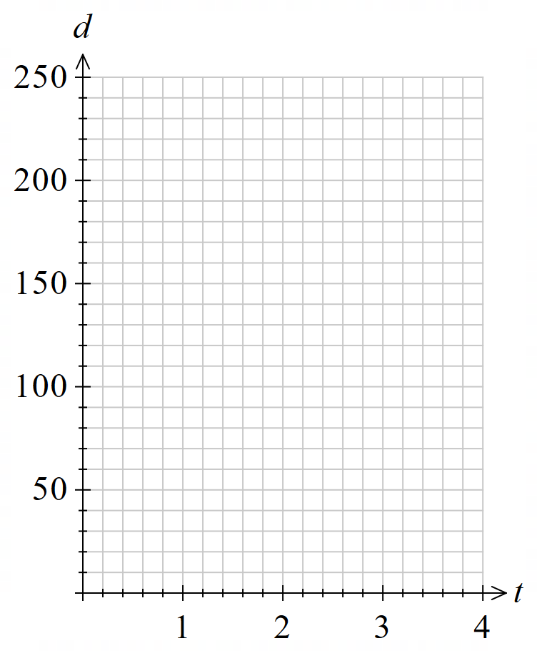
Time (h) $t$ | 0 | 1 | 2 | 3
Distance (km) $d$

What type of graph is this?

This is a …………-line, going through the …………

Find the gradient, which is the constant of variation $k$.

$$m=\frac{rise}{run}=$$

What does $k$ represent in this context?

…………… per ………

Write an equation relating $d$ and $t$:
$y=kx$
…… $=$ ………

- Key Ideas
- A graph of a direct variation relationship is a ……………-line going through the ……………
- The gradient is the ………………… …… …………………, $k$

- Constant of Variation (Direct)
$$y=kx \\ \frac{y}{x}=k$$
One quantity divided by the other will always be a constant value. This is the gradient.

- Example Decide whether a direct variation relationship exists from a table
The distance $d$ of a marathon runner over time $t$is shown on the table.
Determine if a direct variation relationship exists, if it does, write the equation $y=kx$.
$$x$$ | 30 | 108 | 156 | 204
$$y$$ | 5 | 18 | 26 | 34
$$\frac{y}{x}$$ | $$\frac{5}{30}=\frac{1}{6}$$ | $$\frac{18}{108}=\frac{1}{6}$$ | $$\frac{26}{156}=\frac{1}{6}$$ | $$\frac{34}{204}=\frac{1}{6}$$

$∴$ a direct variation relationship exists.
$$y=\frac{1}{6}x$$

- Guided Practice
Determine if a direct variation relationship exists, if it does, write the equation $y=kx$.
yes, $y=2x$ | no
  $$x$$ | 15 | 25 | 35 | 70
  $$y$$ | 30 | 50 | 70 | 140
  $$\frac{y}{x}$$
  $$x$$ | 5 | 9 | 12 | 14
  $$y$$ | 7 | 11.2 | 19.6 | 26.6
no | yes, $y=3.6x$
  $$x$$ | 1 | 2 | 3 | 4
  $$y$$ | 19 | 16 | 11 | 4
  $$m$$ | 5 | 12 | 14 | 18
  $$C$$ | 18 | 43.2 | 50.4 | 64.8

- Key Ideas
- Direct variation relationships are in the form $y=$……, this can be rearranged to $k=$ ……
- We check if two quantities are in direct variation by dividing one quantity by the other and see if the ratio is ……………… for all pairs of values.

Foundation
- Which of the graphs show a direct variation relationship?
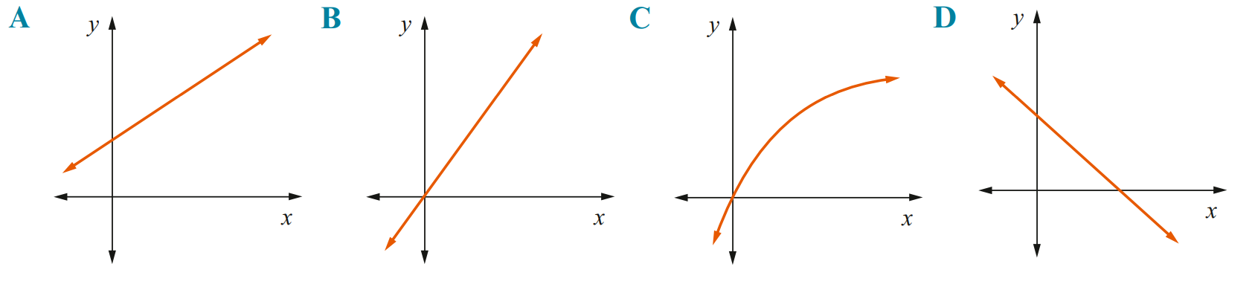

B
- Decide whether $x$ and $y$ are in direct proportion. If they are, write the equation $y=kx$.
no | Yes $y=7x$ | Yes $y=2x$
  $$x$$ | 1 | 2 | 5
  $$y$$ | 4 | 8 | 21
  $$\frac{y}{x}$$
  $$x$$ | 2 | 3 | 6
  $$y$$ | 14 | 21 | 42
  $$x$$ | $$-4$$ | $$-1$$ | 3
  $$y$$ | $$-8$$ | $$-2$$ | 6
Yes $y=2.4x$ | no | no
  $$x$$ | 5 | 30 | 92
  $$y$$ | 12 | 72 | 220.8
  $$x$$ | 3 | 10 | 23
  $$y$$ | 7 | 21 | 70
  $$x$$ | 8 | 11 | 36
  $$y$$ | 11 | 27.5 | 90

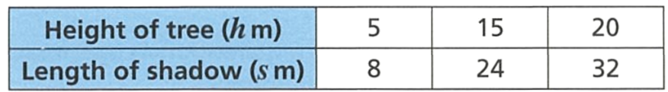
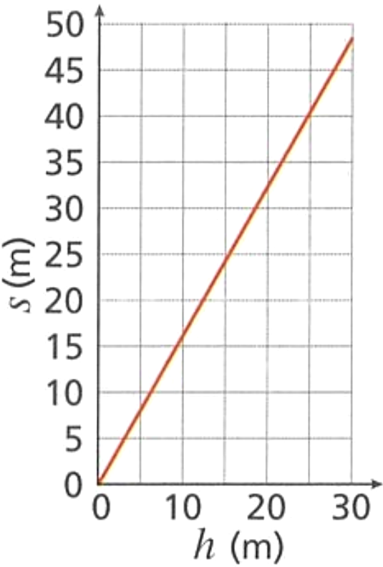
- The table shows the lengths of the shadows of three trees.

  - Calculate the ratio $\frac{s}{h}$ for each tree.
1.6
  - Explain how you know the length of the shadow is proportional to the height of the tree by referring to:
    - the graph
straight line passing through origin
    - the calculations on table
$\frac{s}{h}$ is a constant value, $1.6$
  - Write the equation $y=kx$ showing the relationship between $s$ and $h$ ………………………

$$s=1.6h$$
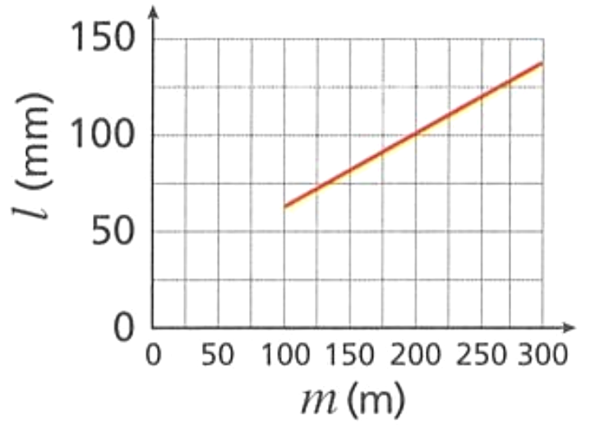
- In a science experiment, different masses are attached to the end of a spring and the length of the spring is measured. The results are shown in the table.
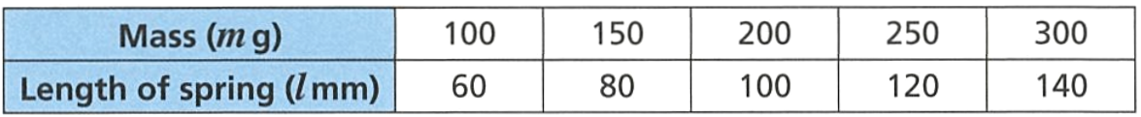

Is the length of the spring directly proportional to the mass of the weight?
no
Explain how you know:
  - by extending the graph
when extended, the graph does not pass through the origin
  - by doing calculations using the numbers in the table.
the ratio of $\frac{l}{m}$ is not constant

- A 750ml bottle of water costs 80 c. A 2 litre bottle of water costs $2.
Show that the cost of water is not directly proportional to the amount of water in the bottle.

Using $\frac{Cost (\$)}{Volume (L)}$
$\frac{0.8}{0.75}$ $=1.0\dot{6}$
$$\frac{2}{2}=1$$
Since $\frac{C}{V}$ is not constant, not direct variation.

Graphs of Inverse Variation

- Inverse Variation
Two quantities are inversely proportional if:
- An increase in one quantity causes a proportional decrease in the other.
- If you triple one quantity, the second quantity is divided by 3.
- A decrease in one quantity causes a proportional increase in the other.
- If you halve one quantity, the second quantity is doubled.

The equation of an inverse variation relationship is $y=$ $\frac{k}{x}$.
An inverse variation graph is a smooth curve;
a hyperbolic decreasing curve that never touches the axes.

- Investigation Graph of an inverse variation relationship
A car needs to travel a journey of 60 km.
The time $t$ required in hours is inversely proportional to speed $s$ in km per hour.
Complete the table of values and sketch the graph.
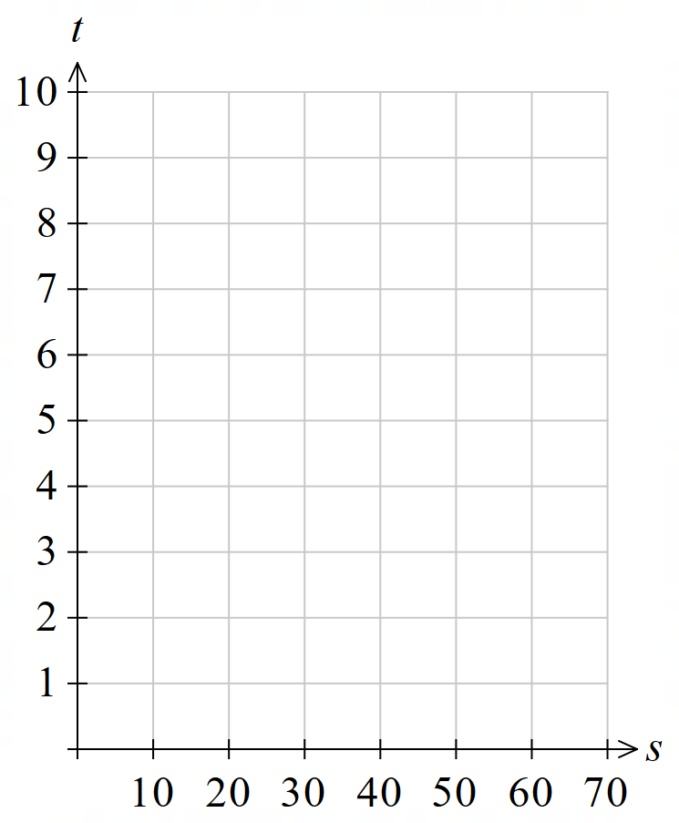
Speed (km/h) $s$ | 0 | 10 | 20 | 30 | 60
Time (h) $t$

What type of graph is this?

This is a h……………… d……………… c……………

Is there a point on the graph for $t=0$?

Is there a point on the graph for $s=0$?

- Key Ideas
- Graphs of inverse variation relationships are a h……………… d……………… c………………
- The graph of an inverse variation relationship never touches the ……………

- Constant of Variation (Inverse)
$$y=\frac{k}{x} \\ xy=k$$
One quantity multiplied by the other will always be a constant value.

- Example Decide whether an inverse variation relationship exists from a table
The time $t$taken to travel a certain distance $d$ is shown on the table.
Determine whether an inverse variation relationship exists.
$$x$$ | 1 | 2 | 5 | 10
$$y$$ | $$60$$ | $$30$$ | $$12$$ | $$6$$
$$xy$$ | $$1×60=60$$ | $$2×30=60$$ | $$5×12=60$$ | $$10×6=60$$

$∴$ an inverse variation relationship exists.
$$y=\frac{60}{x}$$

- Guided Practice
Determine whether the variables in the tables given below are in inverse proportion.
yes | no
  $$x$$ | 1 | 2 | 4 | 6
  $$y$$ | 48 | 24 | 12 | 8
  $$xy$$
  $$x$$ | 1 | 2 | 3 | 4
  $$y$$ | 3 | 6 | 9 | 12
no | yes
  $$x$$ | 1 | 26 | 40
  $$y$$ | 0.2 | 5.2 | 8
  $$m$$ | 1 | 2 | 4 | 8
  $$C$$ | 16 | 8 | 4 | 2

- Key Ideas
- Inverse variation relationships are in the form $xy=k$, where $k$ is the ……………… of proportionality.
- To check whether two variables are in inverse variation, we can multiply one quantity by the other and see if the product is ……………… for all pairs of values.

- Distinguishing Direct and Inverse Variation
Direct Variation | Inverse Variation
$$y=kx$$  Straight line passing through the origin. | $$y=\frac{k}{x}$$  A “hyperbolic” decreasing curve that doesn’t touch the axes.  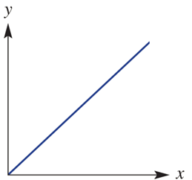  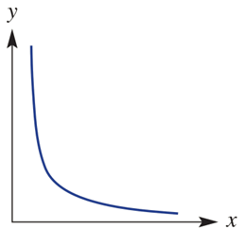

- Identify whether a graph shows direct variation, inverse variation, or neither
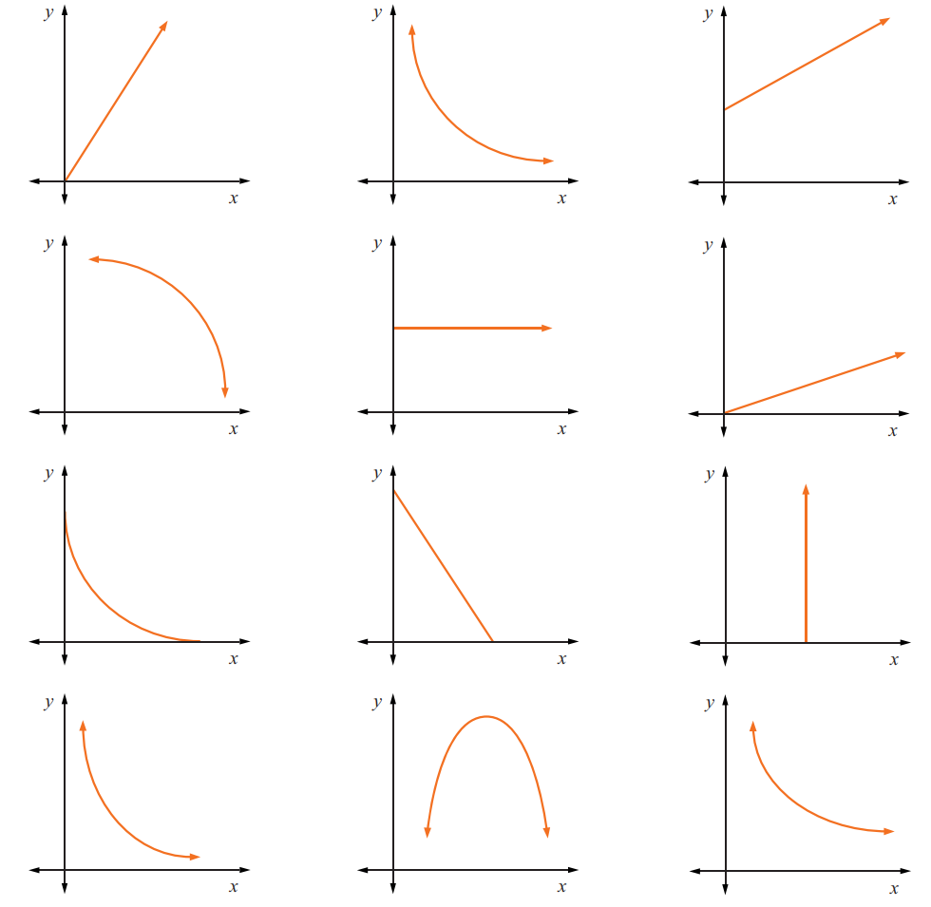

- Key Ideas
- Direct variation graphs are ………………… ………… passing through the ……………
- Inverse variation graphs are ……………… ……………… curves that do not touch the ……

Foundation

- Tina says:
If graph A represents direct proportion,
then graph B represents inverse proportion.

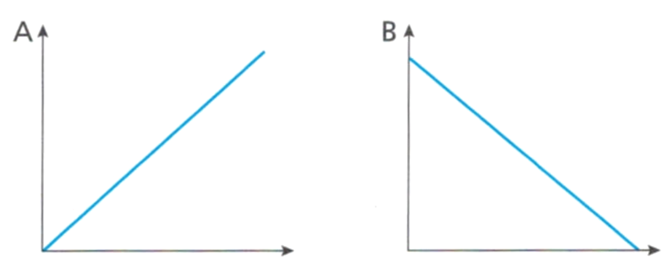

Explain why she is incorrect.

Inverse variation is a hyperbolic curve.
- The variables $x$ and $y$ are inversely proportional.
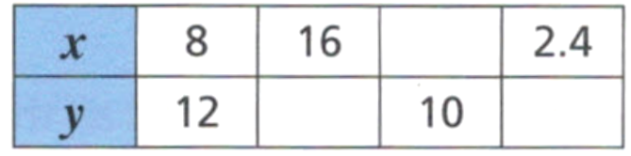

  - Express this relationship in the form $xy = k$, where $k$ is the constant of proportionality.
$$xy=96$$
  - Complete the table.
6, 9.6, 40
- The variables $x$ and $y$ are inversely proportional.
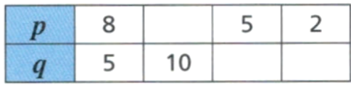

  - Express this relationship in the form $pq = k$, where $k$ is the constant of proportionality.
$$pq=40$$
  - Complete the table.
4, 8, 20

- State whether each table shows direct proportion, inverse proportion, or neither.
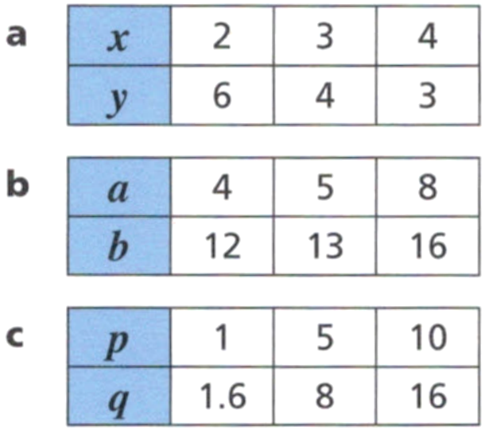  inverse | neither | direct

Solving Direct Variation Problems

- Solving Direct Variation Problems
$y∝x$ indicates a direct variation relationship between the two variables.
- Write $y=kx$
- Substitute given information.
- Solve the equation to find the constant of variation $k.$
- Rewrite $y=kx$ with the $k$ you calculated.
- Use your equation to find the required information.

- Example Find the equation of a direct variation relationship
Given that $y∝x$ and $y=4.5$when $x=13.5$:
- Find $y$ when $x=42$
- Find $x$ when $y=7$
1. $y=kx$  2. $4.5=k(13.5)$  3. $\frac{4.5}{13.5}$ $=k$  $$k=\frac{1}{3}$$ | 4. $y=$ $\frac{1}{3}$ $x$  5. Find $y$ when $x=42:$  $$y=\frac{1}{3}\left(42\right)$$  $$=14$$  Find $x$ when $y=7$:  $$7=\frac{1}{3}x$$  $$21=x$$

- Guided Practice
Given that $y∝x$ and $y=42$ when $x=5$, find:
- $y$ when $x=7$
- $x$ when $y=51$

a) 58.8 b) 6.07
Given that $a∝b$ and $a=9.6$ when $b=1.6$, find:
- $a$ when $b=21$
- $b$ when $a=11$

a) 126 b) $\frac{11}{6}$

Foundation
- $y=kx$ and $y=24$ when $x=8$. Find:
  - The value of $k$ and write the equation.
  - $y$ when $x=4$
  - $x$ when $y=15$

a) $y=3x$ b) $y=12$ c) $x=5$
- $y$ varies directly with $x$ and $y=20$ when $x=10$. Find:
  - $y$ when $x=8$
  - $x$ when $y=12$

a) $y=16$ b) $x=6$
- $a$ varies directly with $b$ and $a=84$ when $b=56$. Find:
  - $b$ when $a=22$
  - $a$ when $b=12$

a) $b=14$ $\frac{2}{3}$ b) $a=18$
- In the tables below $y ∝ x.$ Write the equation and find the values of $a,b,c$.
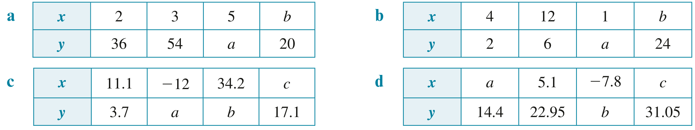  Equation: ……………  $$y=18x, a=90, b=\frac{10}{9}$$ | Equation: ……………  $$y=0.5x, a=0.5, b=48$$
Equation: ……………  $$y=\frac{1}{3}x, a=-4, b=11.4, c=51.3$$ | Equation: ……………  $$y=4.5x, a=3.2,b=-35.1, c=6.9$$

Modelling Direct Variation

- Solving Direct Variation Problems
The goal is to find $k$, then write the equation to solve for the unknowns.
- Write $y=kx$
- Substitute given information.
- Solve the equation to find the constant of variation $k.$
- Rewrite $y=kx$ with the $k$ you calculated.
- Use your equation to find the required information.

- Example Model and solve direct variation problems
Garden mulch is sold in bulk, with the cost $C$ proportional the volume $V$ in cubic metres.
The shop says 7.5 m³ costs $270. How much does 12 m³ cost?
1. $C=kV$  2. $270=k×7.5$  3. $\frac{270}{7.5}$ $=k$  $k=36$ | 4. $C=36V$  5. Finding $C$ when $V=12:$  $C=36×12$  $C=\$432$  12 m³ would cost $432.
What does $k=36$ represent in this scenario? (hint: consider the units)

- Guided Practice
The petrol $P$ used by a car at a constant speed is directly proportional to distance travelled $d$.
A car uses 6 L of petrol to travel 50 km.
How much petrol is needed to travel 180 km?
Finding $k:$  $y=kx$  $P=kd$  What does $k$ represent? | Write the equation:  Find $P$ when $d=180$ km:  21.6 L

The amount of paint $P$ needed to paint a wall is directly proportional to the area covered $A$.
A 4-litre can of paint will cover 12 m².
Find the number of litres of paint needed to paint a 63 m² wall.
Finding $k:$  What does $k$ represent? | Write the equation:  Find $P$ when $A=63$ m²:  21 L

Foundation
- Oscar’s pay $p$ is directly proportional to the number of hours $h$ he works.
For a 9-hour day he receives $193.50.
  - Calculate the constant of variation $k$. What does it represent in this scenario?

$$k=\$21.5/hr$$
  - Write an equation connecting $p$ and $h$.
$$p=21.5h$$
  - What is Oscar’s pay if he works for 11 hours?

$$\$236.50$$
  - What is Oscar’s pay if he works for 6.5 hours?

$$\$139.75$$
  - How many hours does Oscar have to work to earn $365.50?

$17$ hours
- The cost of a photocopier (C, in dollars) varies directly with its speed (s, in pages per minute).
A photocopier with a speed of 50 pages per minute costs $700.
  - What is the constant of variation $k$? What does it represent in this scenario?

$k=\$14$per page per minute of speed
  - Write an equation connecting $C$ and $S$.
$$C=14s$$
  - How much does a photocopier with a speed of 60 pages per minute cost?

$$\$840$$
- The amount of paint $P$, in litres, used to paint a building is directly proportional to the area $A$, in square metres. A certain building requires 48L to cover an area of 576 m².
  - Find the constant of variation and write the equation relating $P$ and $A$.

$$k=\frac{1}{12}, P=\frac{1}{12}A$$
  - A larger building has an area of 668 m² to be painted.
How many litres of paint will this require? Round to 2 d.p.

$55.67$ litres

Development
- The amount of petrol used by a car travelling at a constant speed is directly proportional to the distance travelled. A car uses 6 L of petrol to travel 56 km. How much petrol will be used to travel 140 km at the same speed?

$15$ litres
- The resistance, $R$ ohms, to the flow of electricity in a wire varies directly with the length, $l$ cm, of the wire and, when $l=20$ cm, $R=0.08$ Ohms.
  - Find $R$ when $l=85$ cm.
  - Find $l$ when $R=6$ Ohms.

a) 0.34 ohms b) 1500 cm
- Christopher runs 120 m in 15 s.
  - Write an equation relating distance $d$ and time $t$.

$$d=8t$$
  - What does the constant of variation represent in this scenario?
Include units in your answer.

8 metres per second (the speed)
  - Use your equation to show that Christopher runs 4800 metres in 10 minutes.

$10$ minutes = 600 seconds
$d=8×600=4800$ m
  - Considering your answer to part b, what is a limitation of the linear model?

His speed will not stay constant over 10 minutes as he will slow down when he gets tired; The linear model is not valid for long durations.

Mastery
- 2020 HSC Standard 2 Band 5
The weight of a bundle of A4 paper ($W$ kg) varies directly with the number of sheets ($N$) of A4 paper that the bundle contains.
This relationship is modelled by the formula $W=kn$, where $k$ is a constant.
The weight of a bundle containing 500 sheets of A4 paper is 2.5 kilograms.
Show that $k$ is 0.005.

A bundle of A4 paper has a weight of 1.2 kilograms.
Calculate the number of sheets of A4 paper in the bundle.

240 sheets
- 2014 HSC Standard 2 Band 4
The weight of an object on the moon varies directly with its weight on Earth.
An astronaut who weighs 84 kg on Earth weighs only 14 kg on the moon.
A lunar landing craft weighs 2449 kg when on the moon.
Calculate the weight of this landing craft when on Earth.

14 694 kg
- HSC Standard 2 Sample Question Band 5
The weight of a steel beam, $w$, varies directly with its length, $l$.
A 1200 mm steel beam weighs 144 kg.
Calculate the weight of a 750 mm steel beam.

90 kg

Inverse Variation Problems

- Solving Inverse Variation Problems
- Write $y=$ $\frac{k}{x}$
- Substitute given information.
- Solve the equation to find the constant of variation $k.$
- Rewrite $y=$ $\frac{k}{x}$ with the $k$ you calculated.
- Use your equation to find the required information.

- Example Find the equation of an inverse variation relationship
$y$ $∝$ $\frac{1}{x}$ and $y=4$ when $x=3$.
- Find $y$ when $x=42$
- Find $x$ when $y=7$
1. $y=$ $\frac{k}{x}$  2. $4=$ $\frac{k}{3}$  3.$12=k$  4. $y=$ $\frac{12}{x}$ | 5. Find $y$ when $x=42$:  $$y=\frac{12}{42}=\frac{2}{7}$$  Find $x$ when $y=7$:  $$7=\frac{12}{x}$$  $$x=\frac{12}{7}$$

- Guided Practice
Given $y$ $∝$ $\frac{1}{x}$ and $y=18$ when $x=2$. Find:
  - $y$ when $x=9$
  - $x$ when $y=2$

a) 4 b) 18
Given $y$ $∝$ $\frac{1}{x}$ and $y=3$ when $x=17$. Find:
  - $y$ when $x=102$
  - $x$ when $y=6$

a) 0.5 b) 8.5
- Example Model and solve inverse variation problems
The cost per person of hiring a bus $C$ is inversely proportional to the number of passengers $N.$ When there are 60 passengers, the cost per person is $8.
- Find the cost per person when 45 people go on the bus.
- How many people need to take the bus for the cost to be $6?
1. $C=$ $\frac{k}{N}$  2. $8=$ $\frac{k}{60}$  3. $480=k$  4. $C=$ $\frac{480}{N}$ | 5. Find $C$ when $N=45$:  $$C=\frac{480}{45}$$  $$=\$10.67$$  Find $N$ when $C=6$:  $$6=\frac{480}{N}$$  $$6N=480$$  $$N=\frac{480}{6}=80 people$$
What does $k$ represent in this scenario? (Hint: what does $60×\$8$ find?)

- Guided Practice
The number of painters $N$ is inversely proportional to the amount of time to paint a fence $t$.
3 painters can paint a fence in 12 hours. Find:
- Find how many painters are needed to paint the fence in 9 hours.
- How long it would take 2 people to paint the fence.

a) 4 painters b) 18 hrs

Foundation
- $y$ is inversely proportional to $x$ and $y=42$ when $x=6$. Find:
  - Write an equation $y=\frac{k}{x}$ and calculate the constant of variation.

$$y=\frac{252}{x}$$
  - What is $y$ when $x=3$?
$$84$$
  - What is $x$ when $y=21$?
$$12$$

- It is known that $y$ varies inversely with $x$. If $y=6$ then $x=8$.
  - Write an equation $y=\frac{k}{x}$ and calculate the constant of variation.

$$y=\frac{48}{x}$$
  - Find the value of $y$ if $x=24$
$$2$$
  - Find the value of $x$ if $y=4$
$$12$$

- Time taken in hours $(t)$ for a trip varies inversely with average speed $(s)$.
It takes 5 hours to complete a trip travelling at 68 km/h.
  - Find the constant of variation.

340
  - Write an inverse variation equation to describe this situation.

$$t=\frac{340}{s}$$
  - What is the time taken for a trip with an average speed of 34 km/h?

10 hours
  - What speed is required to complete the trip in 4 hours?

$85$ km/h

- The cost per person ($c$), in dollars, to attend a formal dance varies inversely with the number of people ($n$) attending. When 90 people attend, the cost is $60 per person.
  - If only 80 people attend the formal dance, how much will each person have to pay?

$67.50
  - The organising committee has suggested a cost per ticket of $40.
How many people need to attend the formal dance for the tickets to be $40?

135
- The number of people ($N$) who attend a show varies inversely with the amount of floor space (in cm² ) allowed per person ($A$). A venue can hold 480 people if each person is allowed 2000 cm².
  - How many people could the venue hold if each person was allowed 2400 cm²?

400
  - What is the space allowed per person to allow 500 to attend the show?

1920
- 4 workers can resurface a road in 6 hours.
  - How long would it take to resurface the same road if 6 people worked together?

4 hours
  - How many workers are needed if the road is to be resurfaced in 3 hours?

8 workers

Development
- Squeaky Clean Windows can clean all windows of a building in 5 days when it hires 8 people.
This year the client wants the job completed in 4 days.
How many cleaners are required?

10
- Connor uses a microwave oven to reheat a meal.
The time taken (in minutes) for heating is inversely proportional to the power setting.
The meal takes 3 minutes at a power setting of 60%.
How long would it take at a power setting of 80%?

2 min 15 sec
- 4 people take 1 hour and 20 minutes to water a football pitch.
How long would it take to water the same pitch if 5 people worked together?
Give your answer in hours and minutes.

1 hr 4 min
- It takes one day for 2 workers to harvest a crop from a field with an area of 40 m².
Mario's farm has an area of 320 m².
He hires 8 workers and pays each of them $180 per day.
How much will it cost him to harvest his crop?

$2880

Mastery
- 2021 HSC Standard 2 Band 5
The time taken to clean a warehouse varies inversely with the number of cleaners employed.
It takes 8 cleaners 60 hours to clean a warehouse.
Working at the same rate, how many hours would it take 10 cleaners to clean the same warehouse.

48 hours
- HSC Standard 2 Sample Question Band 5
The number of trees that can be planted along the fence line of a paddock varies inversely with the distance between each tree. There will be 108 trees if the distance between them is 5 metres.
  - How many trees can be planted if the distance between them is 6 metres?

90
  - What is the distance between the trees if 120 trees are planted.

4.5 m

